Pranjal Singh

JFreeChart Documentation

I am doing the JFreeChart implementation of the plot salt and smooth program. I did not make this program have an input or output of CSV because the main focus is to have it display a graph. As far as the x value goes, I never have to update it, so the x remains the same between all data manipulators. The function for this is the same, being $y = x^{2}+13$.

Plotting

Just used a simple for loop to assign the values to the ArrayList

Salting

The salting values used were -2500-2000

Smoothing

To smooth the values, I chose to use the same method as the first smoother. The window I used was 15.

The red line is the normal plotted line $y = x^{2}+13$

The blue line is the salted line

The green line is the smoothed line from the blue line

As you can see, it is very close to the original graph. The smoothing amount of 15 seemed to work the best

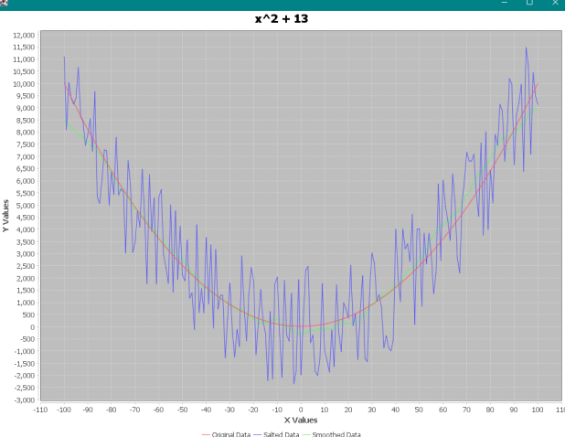

Then, I increased the salting range from -10000 to 10000. I also had to increase the window for smoothing to account for the larger range. I increased the window value to 30. Since the variance is much larger, it is harder for the algorithm to accurately smooth the graph to the level of the less sparse graph from the salter.

